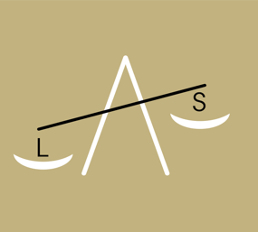
Association of Law Secretaries to the Justices of the Supreme and Surrogates’ Courts in the City of New York
Parking Placard Application

Name: _______________________________________________________________________________
Home Address: _______________________________________________________________________

Phone Number: _______________________________________________________________________

Make of the Car: ______________________________________________________________________
Model of the Car: _____________________________________________________________________
License Plate #: ______________________________________________________________________
State of Car Registration: ______________________________________________________________

Email Address: _______________________________________________________________________
Job Title: _____________________________________________________________________________
Job Address: _________________________________________________________________________
Date: ________________________________________________________________________________

Important: If you currently have a 2025-2026 parking placard, you must return the placard to ALS by no later than May 29, 2026 in order to receive your new placard. Parking placards may be returned to your local Borough Reps.

